Poisson distribution
key words: Poisson distribution-probability density function of Poisson distribution-cumulative function of Poisson distribution-Poisson distribution(moment generating function)-Poisson distribution meaning-Poisson distribution variance.
Abstract:
There are tw0 main characteristics 0f a P0iss0n experiment.
- The Poisson probability distribution gives the probability of a number of events occurring in a fixed interval of time or space if these events happen with a known average rate and independently 0f the time since the last event. For example, a B00K editor might be interested in the number of words spelled incorrectly in a particular book. It might be that, 0n the average, there are five words spelled Incorrectly in 100 pages. The Interval is the 100 pages.
- The Poisson distribution may be used to approximate the binomial if the probability of success is “small” (such as 0.01) and the number of trials is “large” (such as 1,000). You will verify the relationship In the homework exercIses. n is the number of trials, and p is the probability of a “success.”
The random variable X=X= the number of occurrences in the interval of interest.
Notation for the Poisson: P=P= Poisson Probability Distribution Function
X∼P(μ)X∼P(μ)
Read this as “X is a random variable with a Poisson distribution.” The parameter is μμ (or λλ); μμ (or λλ)== the mean for the interval of interest.

Contents:
Mean and Variance of Poisson Distribution
If μ is the average number 0f successes occurring in a given time interval 0R region in the Poisson distribution, then the mean and the variance of the P0iss0n distribution are both equal to μ.
E(X) = μ
and
V(X) = σ² = μ
Note: In a Poisson distribution, only one parameter, μ is needed to determine the probability of an event.
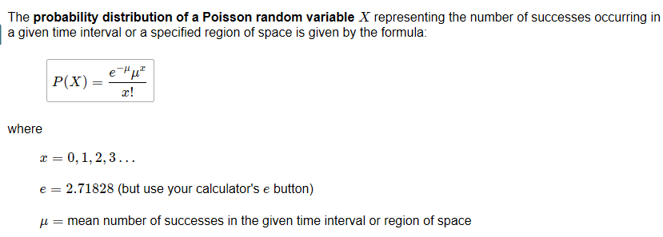
Properties of Continuous Probability Distributions
The graph of a continuous probability distribution is a curve. Probability is represented by area under the curve.
The bend is known as the likelihood thickness work (abridged as pdf). We utilize the image f(x) to speak to the bend. f(x) is the capacity that relates to the chart; we utilize the thickness work f(x) to draw the diagram of the likelihood conveyance. Region under the bend is given by an alternate capacity called the combined dispersion work (curtailed as cdf). The aggregate dissemination work is utilized to assess likelihood as region.
Area under the curve is given by a different functi0n called the cumulative distribution function (abbreviated As cdf). The cumulative distributi0n function is used to evaluate probability as area.
- The outcomes are measured, not counted.
- The entire area under the curve and above the x-axis is equal to one.
- Probability is found for intervals of x values rather than for individual x values.
- P(c<x<d)P(c<x<d) is the probability that the random variable X is in the interval between the values c and d. P(c<x<d)P(c<x<d) is the area under the curve, above the x-axis, to the right of c and the left of d.
- P(x=c)=0P(x=c)=0 The probability that x takes on any single individual value is zero. The area below the curve, above the x-axis, and between x=cx=c and x=cx=c has no width, and therefore no area (area=0=0). Since the probability is equal to the area, the probability is also zero.
- P(c<x<d)P(c<x<d) is the same as P(c≤x≤d)P(c≤x≤d) because probability is equal to area.
We will find the area that represents probability by using geometry, formulas, technology, or probability tables. In general, calculus is needed to find the area under the curve for many probability density functions. When we use formulas to find the area in this textbook, the formulas were found by using the techniques of integral calculus. However, because most students taking this course have not studied calculus, we will not be using calculus in this textbook.
There are many continuous probability distributions. When using a continuous probability distribution to model probability, the distribution used is selected to model and fit the particular situation in the best way.
In this chapter and the next, we will study the uniform distribution, the exponential distribution, and the normal distribution. The following graphs illustrate these distributions.
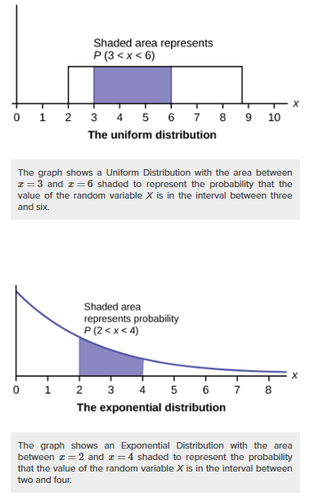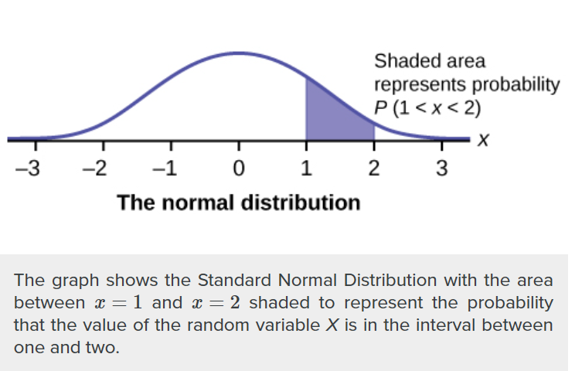
The Graph of the Poisson Function
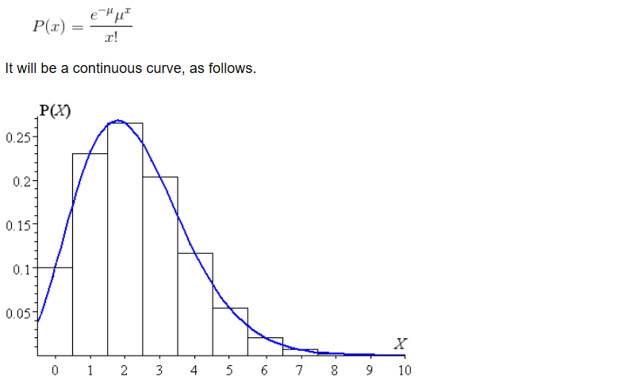
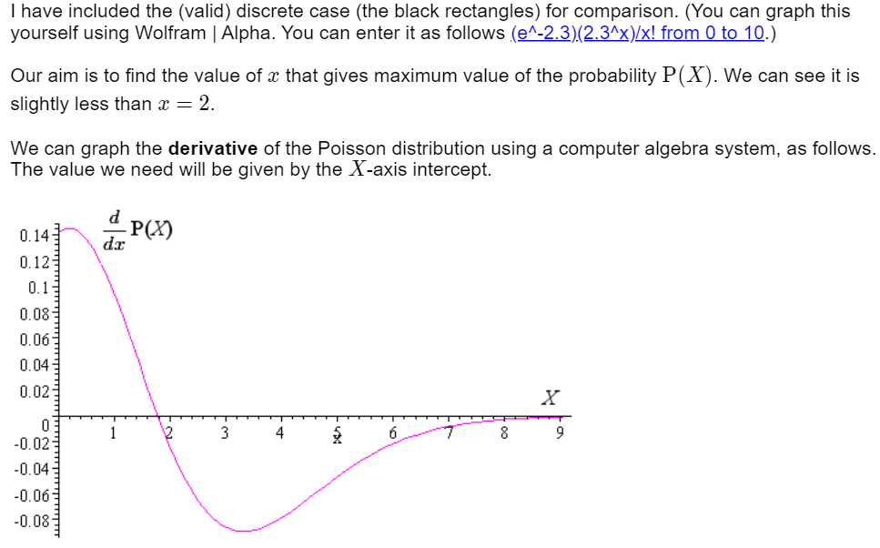
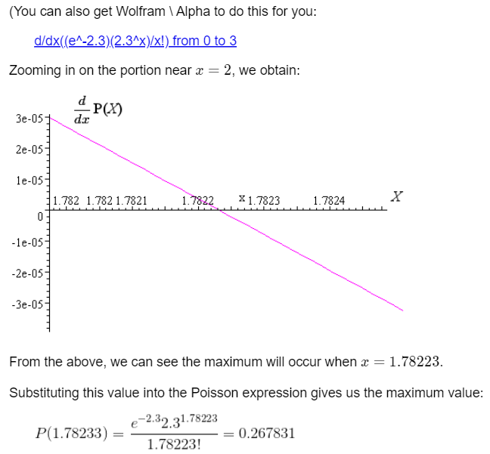
Conclusion:
0ur result tallies nicely with the graph of the "continuous" P0iss0n Distribution above. That is, we have successfully found the "maximum". We did It using graphical means, since an algebraic approach appears rather 0bscure.
However, while we have discovered a theoretical "most extreme" estimation of the Poisson distribution for this model, it isn't substantial since Poisson Distribution just applies for discrete, countable factors.

Moment generating function of Poisson
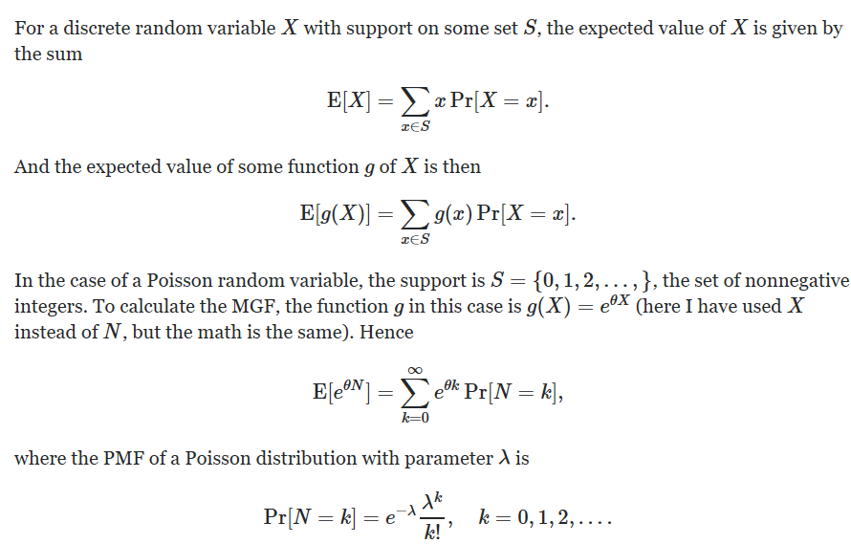
Examples:
A life insurance salesman sells on the average \display style {3}3 life insurance policies per week. Use Poisson's law to calculate the probability that in a given week he will sell
- Some policies
- \display style {2}2 or more policies but less than \display style{5}5 policies.
- Assuming that there is \display style {5}5 working days per week, what is the probability that in a given day he will sell one policy?
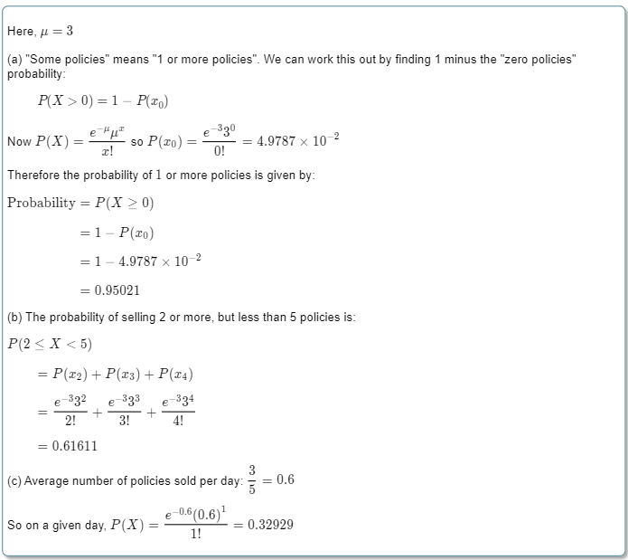
Example: Twenty sheets of aluminum alloy were examined for surface flaws. The frequency of the number of sheets with a given number of flaws per sheet was as follows:
Number of flaws | Frequency
\display style{0}0 | \display style{4}4
\display style{1}1 | \display style{3}3
\display style{2}2 | \display style{5}5
\display style{3}3 | \display style{2}2
\display style{4}4 | \display style{4}4
\display style{5}5 | \display style{1}1
\display style{6}6 | \display style{1}1
What is the probability of finding a sheet chosen at random which contains 3 or more surface flaws?
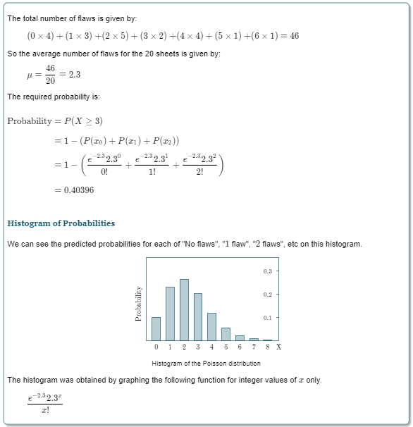

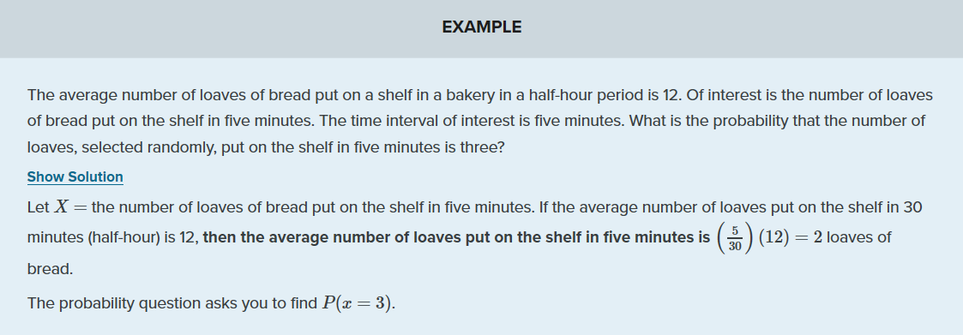
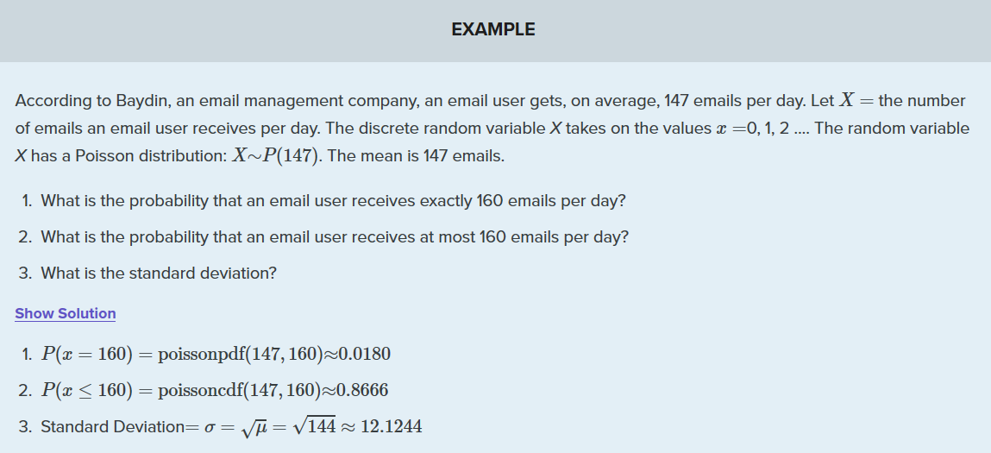

Applications:
- the number of deaths by horse kicking in the Prussian army (first application)
- birth defects and genetic mutations
- rare diseases (like Leukemia, but not AIDS because it is infectious and so not independent) - especially in legal cases
- car accidents
- traffic flow and ideal gap distance
- number of typing errors on a page
- hairs found in McDonald's hamburgers
- spread of an endangered animal in Africa
- failure of a machine in one month

References:
https://courses.lumenlearning.com/introstats1/chapter/poisson-distribution/
https://www.intmath.com/blog/mathematics/maximum-value-of-a-poisson-distribution-4327
https://planetcalc.com/7708/
https://math.stackexchange.com/questions/965319/moment-generating-function-of-poisson

